ECPHRASTIC POETRY ACTIVITY
HISTORY

Using the given stimulus material, create the following types of poetry:
- Free verse
- Acrostic
- Cinquain
- Haiku
- Limerick
Remember to complete the following steps:
- View a stimulus image and identify a history-related concept it evokes.

- If required, write down the concept, definition, law, formula etc.

- Identify a suitable poetry type and write the poem.

STIMULUS IMAGE 1
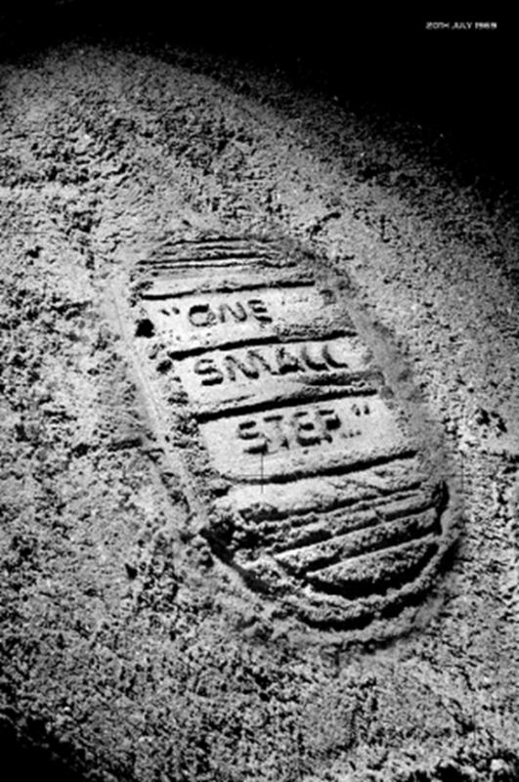
http://9500160365samuelbrandner.files.wordpress.com/2010/09/luna-footprint2.jpg
STIMULUS IMAGE 2
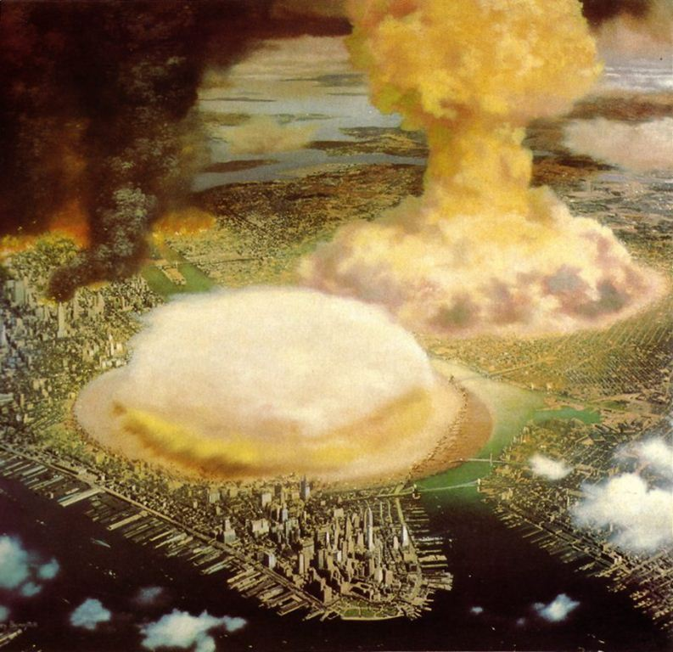
http://www.fabiofeminofantascience.org/BONESTELL/nukebonestell.jpgpg

STIMULUS IMAGE 3
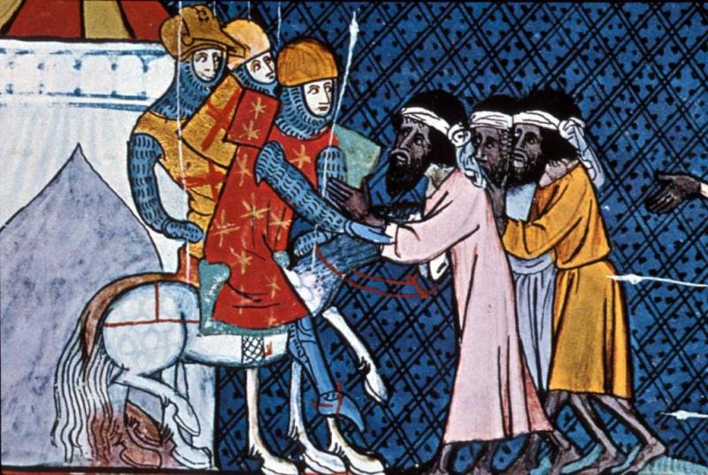
http://www.usu.edu/markdamen/1320Hist&Civ/slides/15crusad/crusaders&moslems.jpg

STIMULUS IMAGE 4
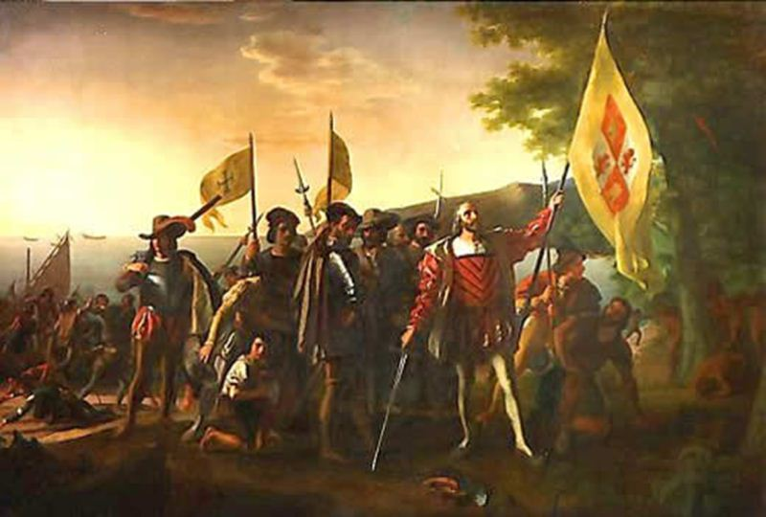
http://theundergroundconservative.files.wordpress.com/2011/10/landing_columbus.jpg

STIMULUS IMAGE 5
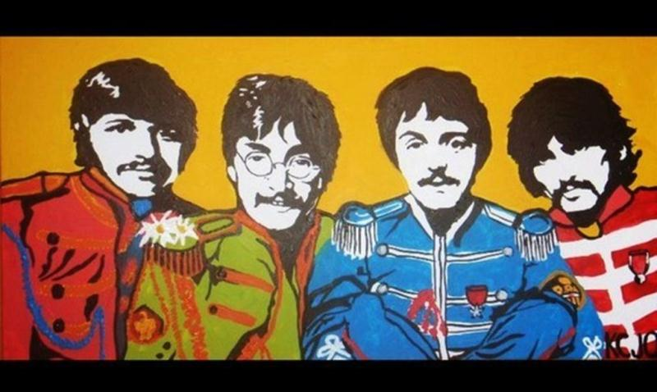
http://images4.fanpop.com/image/photos/17200000/Beatles-painting-for-sale-the-beatles-17295325-570-341.jpg

